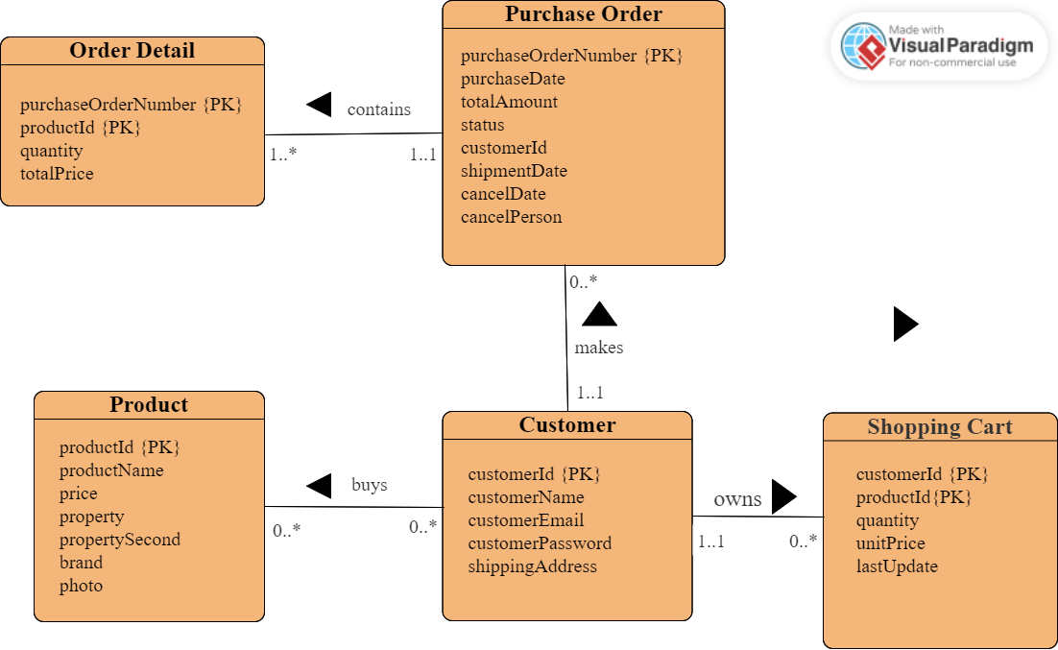

Figure illustrates our ER diagram for Niubility. The main entities are:

* Customer: This entity stores information about each customer who registers on our website, including their names, email addresses, password and shipping addresses.
* Product: This entity stores information about each product that is available for sale on Niubility, such as its name, price, two properties, brand and photo.
* Shopping Cart: This entity stores information about each product the customer wants which includes its quantity, unit price and date when it is added.
* Purchase Order: This entity stores information about each order the customer makes, like purchase date, total amount, order status and customer Id. If the products of this order are shipped, it will record the shipment date. Or the order is canceled, it will record cancel person and cancel date.
* Order Detail: This entity stores the detailed information of each order, such as the specific product(productId), the number of the specific product and the total price of this product.

The relationships between these entities are:

* A customer can buy zero or many products. A product can be bought by zero or many customers.
* A customer can own zero or many shopping carts(Note: the entity Shopping Cart records one product and one customer at one time. You could read the figure below to get better understanding). A shopping cart can be owned by one and only one customer.
* A customer can make zero or more purchase orders. A purchase order can be made by one and only one customer.
* A purchase order can contain one or many order details. But a order detail can be contained by one and only one purchase order.

|  |  |  |  |  |
| --- | --- | --- | --- | --- |
| customerId | productId | quantity | unitPrice | lastUpdate |
| 1 | 6 | 2 | 5000 | 2023-3-26 15:00:06 |